EZ Reports New Grantees -Cohort 15
New Grantees-Must complete all the required information as outlined below. They must be completed in the order stated. Below is a checklist to follow:
Grantee Interface
- School Year 2020-2021 Dates Page 2
- Partners/Providers Page 3
- Grant-4. Partners added Page 4
- Activities Page 5
- Holidays Page 6
- Grade Information Page 7
Site Interface
- Selecting Attendance and Enrollment Options Page 10
- Add/Edit 21st CCLC Staff Page 11
- Add sessions Page 12
- Register Students Page 15
- Enroll Students Page 17
- Attendance Page 19
- Add/Edit School Day Teachers Page 22
- Add Adults/Special Events Page 24/26

Steps to be completed to set up your EZ Reports program
To Logon
https://www.ezreports.org/alabama2021
Step One Checking the School Year Dates
On the Grantee Interface
- Go to Programs on the Home Page.

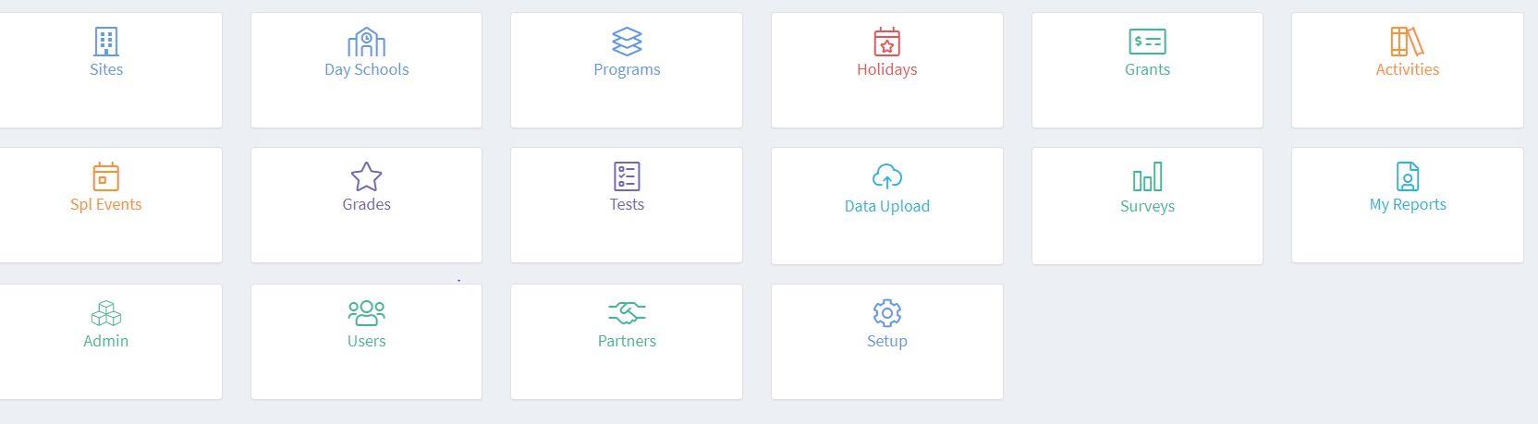
On the screen below click on School Year 2020-2021.
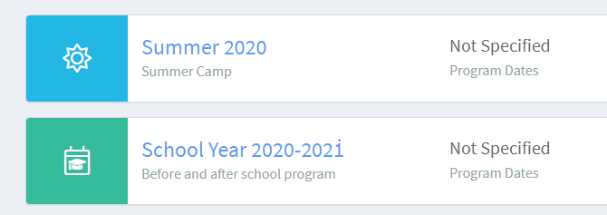
Check the Start and End Dates for your centers.
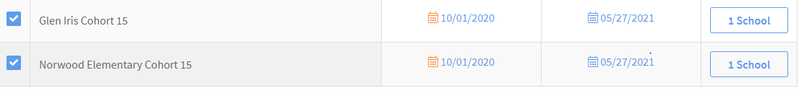
If they are correct, Save. If not, click on the incorrect date and change it. Then Save.

Step Two Adding/Checking Partners/Providers to EZ Reports
Consult your eGap grant application and add all the Partners cited in the grant if they are not already there. To check or add them go to Admin and select Partners/Providers.
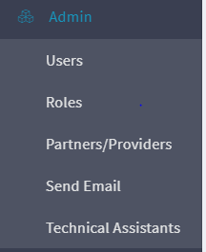
Click on Add Partner and complete all the sections with red asterisks. Save. Add all partners. If they are already in the list you do not need to do anything here.
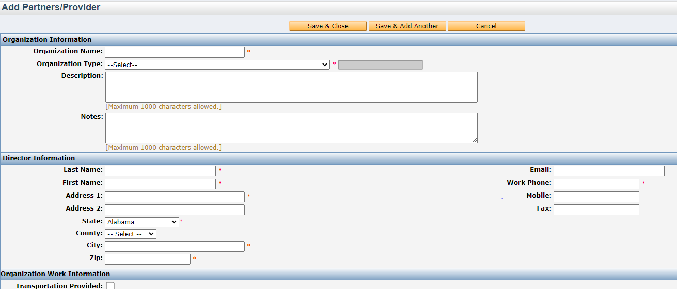

Step Three Adding the Partners to the Grant
On your Homepage go to Grant and click on the name of the grant you need. On this page select 4. Partners
Then click on Select Partner.
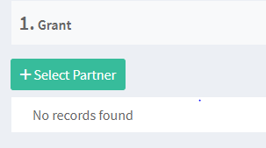
From the Partner Select drop down menu select your first partner. Then fill out the required information below for that partner. Save and then add your remaining active partners.

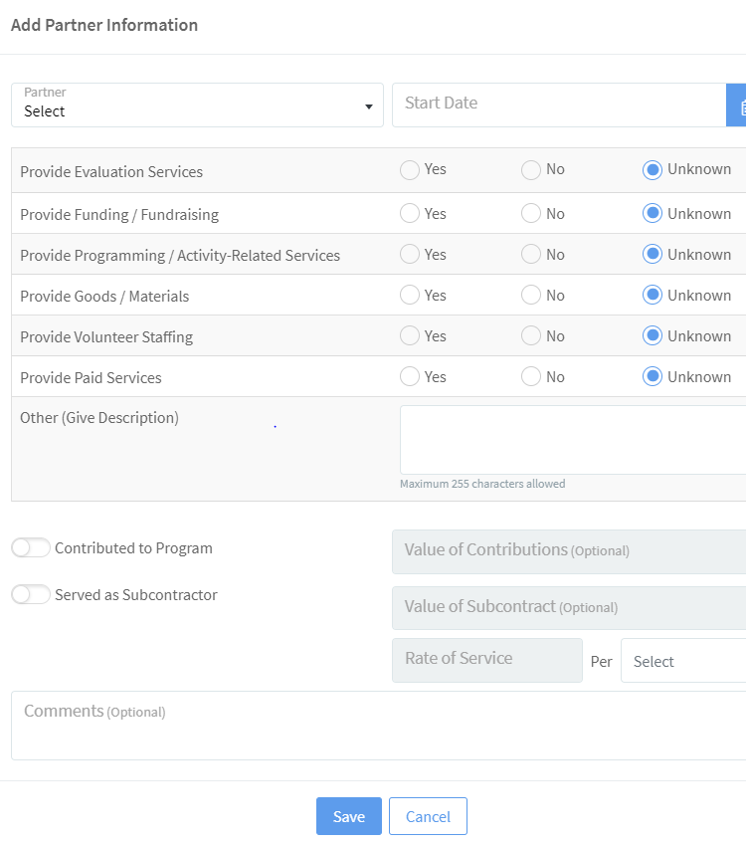
Step Four Adding/Checking on Activities
IMPORTANT-Activities are broad categories. For example, Physical Activity. The sessions that are added on the Site Interface are detailed and specific such as Yoga, Karate or Zumba. When checking or adding Activities be sure to consult your grant application to ensure you include all activity categories included in your grant. The following list is a good place to start:
STEM Literacy
Homework Help Art & Music
Physical Activity Community Service/Service Learning
To add or review your Activities go to Activities and select Regular Activities. If you need to add an activity select Add Regular Activity. Complete all fields with a red asterisk. You can only select one category for an activity. Choose the most appropriate one. However, remember you need to create at least one activity for the categories you included in your grant.
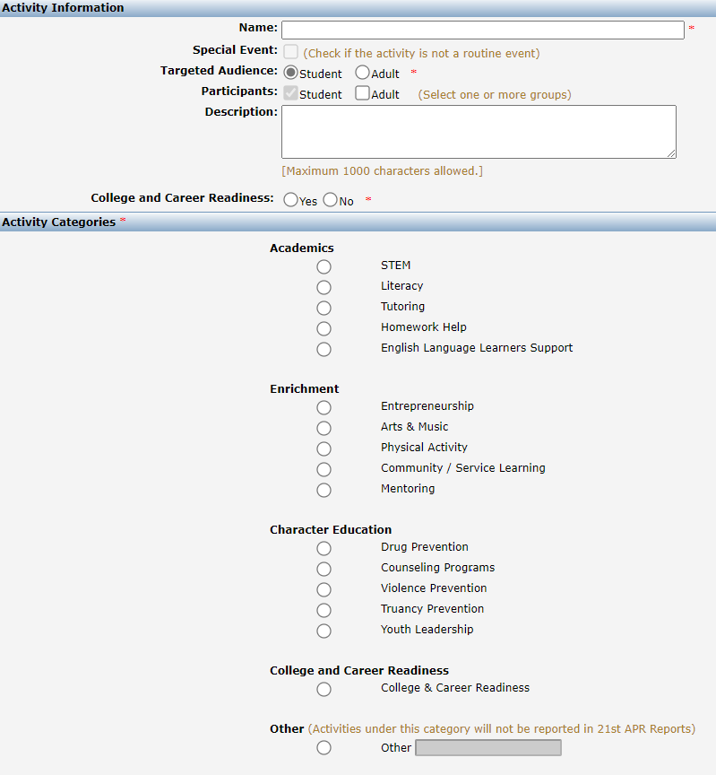
For each Activity you add you MUST complete the additional three Tabs-Grants, Objectives and Site. Those three Tabs are very short and associate the activity with the appropriate grant, objective and site.
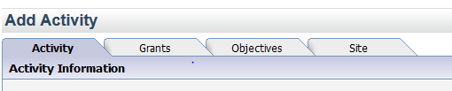

On the Grants page you will see a list of grant(s). Select the one(s) you would like this activity to be associated with and then click Save and Continue.
On the Objectives page check the boxes next to the objectives that this activity will be used to achieve or measure and then click Save and Close.
On the Site page all sites associated with the grants that you checked on the grants page should appear here, now check the site names that should use this activity category. Click Save and Close.
You will return to the main Activity page. The new Activity should be listed there. Do this for all activities. This information will populate the Site Interface Activity section.
Step Five Putting in School Holidays
On the Home page go to Holidays. Select Scheduled Holidays.
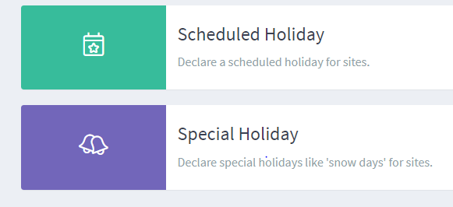
Select Add. Complete the Name, Start and End Date fields. Then check the site(s) the holiday with which it is associated. Add all scheduled school holidays.
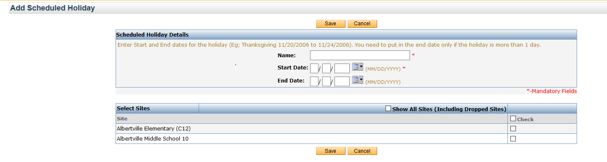
Step Six Grade Information
Go to Home Page and select Grades.
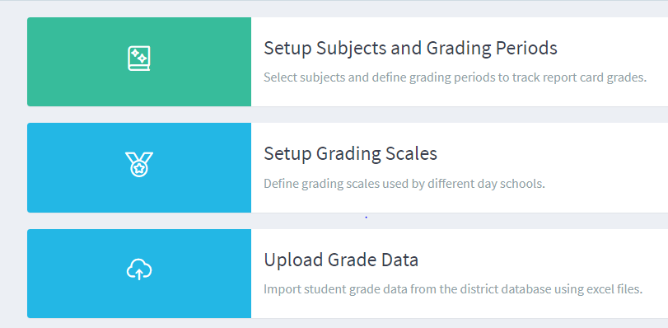

First select Setup Subjects and Grading Periods. You will see that English/Reading and Mathematics has been selected by the state department as required. You will also notice that First Semester grades and Second Semester grades are also required. If you do not need to make any changes you still must click on Save Grading Periods in order to activate the subjects and grades.
Second select Setup Grading Scales. EZReports allows you to define different number and letter grades for each school.
To specify a grading scale, go to 'Outcomes Grades Setup Grading Scales' and enable 'Letter Grades' or 'Number Grades' for each school.
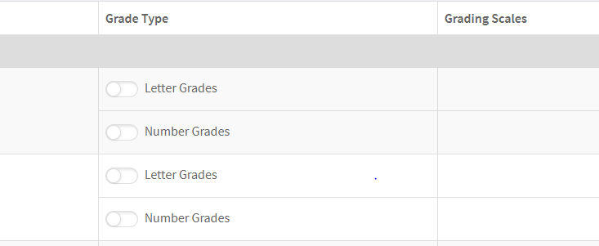
When you enable 'Letter Grades', you are taken to a screen where you can define the letter grades in ranking order starting with the highest letter grades in the first column.
The 'A Equivalent' column specifies all letter grades that are equivalent to getting an A grade. The same logic applies for the remaining columns. If you want to use the standard grades used in most schools, select the 'Add A, B, C, D, F' button to automatically use the 'A', 'B', 'C', 'D', 'F' letter grades. Alternatively you can choose the 'Add A+, A, A-' button to automatically use the 'A', 'A+', 'A-' grade format. If you wish to add more letter grades, use the '+ Add More' link.
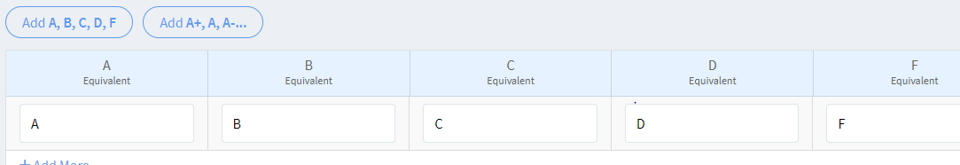
The same grading scale can be used for other schools if required. After enabling this option, schools are displayed below. Select the ones for which you want to apply the same grade scale. Click on 'Save & Close' to complete the process. To make changes, you can click on the 'Letter Grades' link for the school on the 'Grading Scales' page.
Similarly, when you enable 'Number Grades', you are taken to a screen where you can define marks in a ranking order starting with the highest ones in the 'A Equivalent' column. For example, in the screenshot below, a score of 90 to 100 qualifies for the highest 'A' grade, followed by 80-89 which is considered as the next 'A' grade equivalent. To use the standard 100 grading scale followed by most schools, click on the 'Add 100 point scale' button.
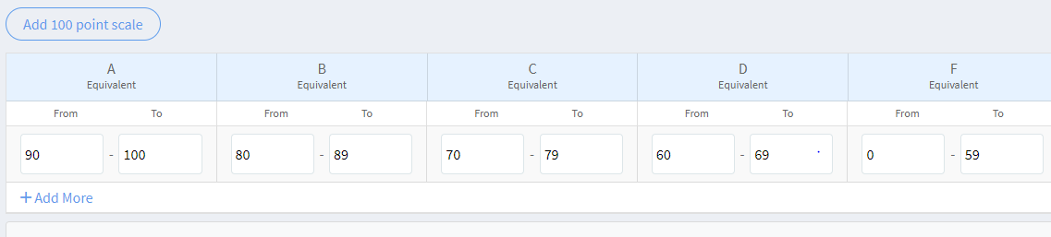
*If you need additional information on Grading Scales go to Support and download the User Guide. Go to Outcomes-Student Grades-Setup Grades or watch the Training Video titled Grades Setup.
Once you have completed these six steps you have completed all required information on the Grantee Interface.

Site Interface Steps to Complete
Step One Selecting Attendance and Enrollment Options
On the Site Interface go to Setup and select Options. The page below should appear. The selections below are the options with the least amount of work. I would recommend you choose these unless you are using a mobile device. This will provide you with a weekly roster in which you only need to take attendance once a day.
Select: Manual Enrollment
Site Attendance (DO NOT SELECT ACTIVITY ATTENDANCE. It is the default position. So it is already checked. Once you check Site Attendance it will disappear.)
Then select Present/Absent Rosters
Also select Staff/Provider-Session Links allowing both staff and providers to be linked to concurrent sessions.
Your page should look just like the one below. Click Save. You should be good to go.
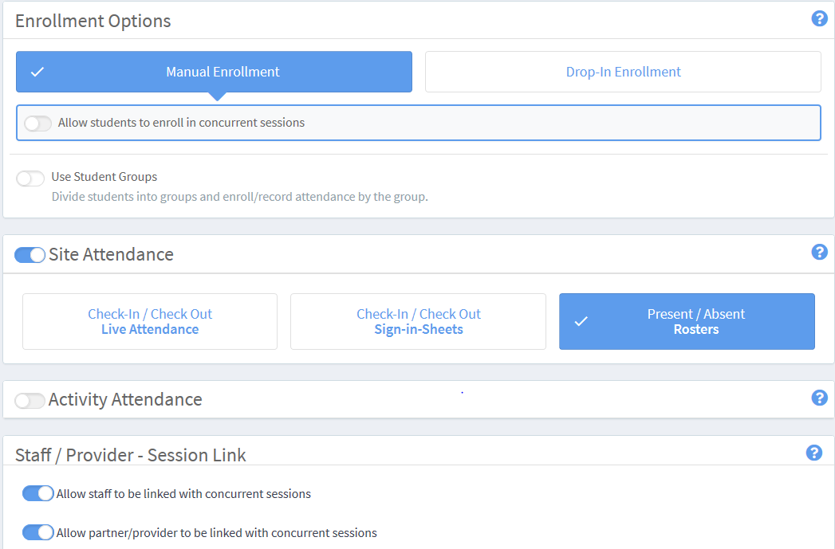
If you had a Cohort 13 grant you still must go into this page and approve the previously selected options.

Step Two Add/Edit 21st CCLC Staff
This should be completed before adding sessions as you need to link the Staff to the sessions.
On the Site Interface go to Admin and select Staff.
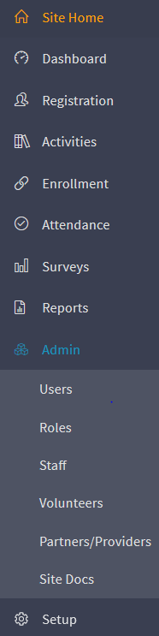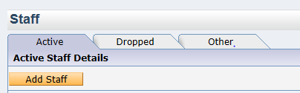
Click on Add Staff. Complete all fields with a red asterisk. Add all staff who are paid or volunteer for your 21st CCLC program including any high school or college students and parent volunteers. This information is shared with the DOE.
REQUIRED STAFF INFORMATION: For your convenience a form that can be distributed to staff with all the requirements is included in your packet. Have them complete it, return it to you and then input the information into EZ Reports.

Step Three Add Sessions
Sessions
To add sessions (specific days, times, dates, grade levels served, etc.) On the Site Interface go to Activity and click on Regular Activity
Go to the Activity that matches the session you are adding and click on the green plus sign to the far right. For example, if you are adding a homework help session you would look for the Activity titled “Homework”. Then click on the green plus sign to the far right.
It will bring up the following page:
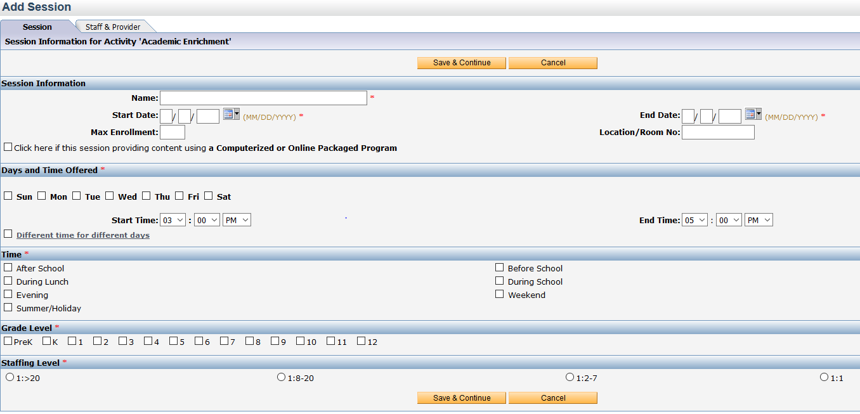
Complete: Fields with red asterisk* Other fields are optional.
Name of session
Start and end date
Days Offered
Start and End time
Time (After School, During School, Evening, etc.)
Grade level (Grade levels attending this session)
Staffing Level (Usually 1:8-20 ratio)
Click Save and Continue. If all required fields are complete and accurate the click will take you to the Staff & Provider page.
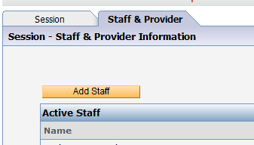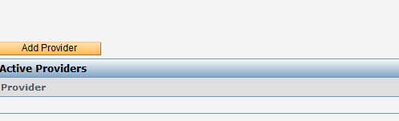
Add Staff who participate in that specific session. If you have volunteers that assist add them too. If you have a provider participate such as the YMCA or Music Teacher add those as well. They will be listed under the Add Provider button.
When you click on the Add Staff or Provider button a pop up window will appear. All of the staff you uploaded into EZ Reports on the Site Interface and all of the Partner/Providers who were uploaded in the Grantee Interface will be listed. Click on the appropriate person(s) or provider(s) and input a start date. Click on either Save.
THE STAFFING INFORMATION IS REPORTED TO THE DOE. THEREFORE, IT IS IMPORTANT THAT YOU ASSOCIATE ALL THE STAFF WITH THE SESSIONS IN WHICH THEY TAKE PART.
When all the staff associated with that session have been added click Save & Close. You should be back on the Regular Activity page. Now you will see the session under the appropriate Activity.
Activities and Sessions
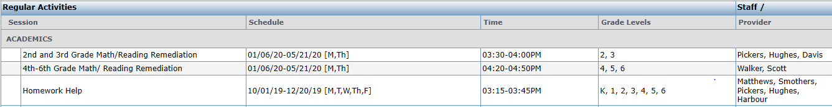

Creating Sessions Helpful Hints
- Individual students cannot be enrolled in two sessions at the same time. For Example, Sally Smith cannot be enrolled in Homework Help on Mondays from 3:00-3:30 and enrolled in Gymnastics at the same time.
- Most sessions are grade specific so look at those students and what they do on a regular weekly basis and map out their week without conflicts. There is an example below:

Schedule for 4th-5th graders in 21st CCLC Program
 | Monday | Tuesday | Wednesday | Thursday | Friday
3:00-3:30 | Homework Help/Tutoring | Homework Help/Tutoring | Homework Help/Tutoring | Homework Help/Tutoring | P.E.
3:30-4:00 | Music/Chorus | Karate | Music/Piano | Sports | Service Learning
4:00-4:30 | Reading Enrichment | Math Enrichment | Reading Enrichment | Math Enrichment | Service Learning
4:30-5:00 | Art/Drama | STEM | Art/Drama | STEM | Service Learning
5:00-5:30 | Character Ed | STEM | Character Ed | STEM | P.E.

There are no conflicts for the 4th and 5th graders in this schedule. Some days the schedule or times might change a little but the basic outline is correct and that is what is most important.
Do this for all of your groups prior to putting sessions into EZ Reports and inputting them will be quick and easy.

Helpful Hints:

List your Activities: Stem, Art and Music, Literacy(Reading/English), Physical Activities, Homework Help, Service Learning, etc.

Think-Generally how much time each week do you spend on that specific activity. Ex. Homework Help-4 times a week for about a half hour.

Create sessions under Homework where the students go M, Tu, W, Th from 3:00-3:30. The exact times are not as important as the correct amount of time and not having time conflicts.

Step Four Registering Students

If you had a previous grant first scroll down to Option Two. Then add remaining new students using Option One.

A student Registration Form is in the packet.

Option One-To Add Students One by One (Site Interface)

Adding Students: Go to Registration → Students, click on the “Add Student” button.
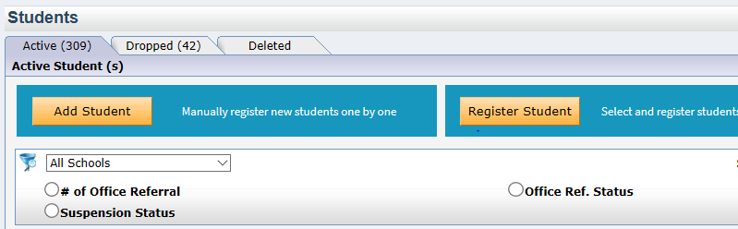If the student has a sibling already entered in EZReports you can click “OK” on the pop up box that appears. Then, search for the last name of the student and select the name of the sibling. This will fill in all general fields such as address and parent information. If the student does not have a sibling entered in EZReports click “Cancel”. You will see the screen below.
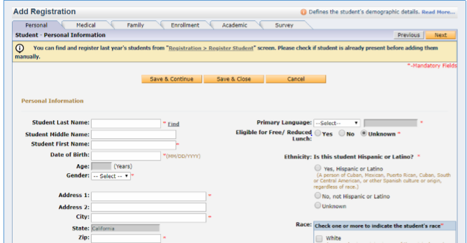
Finish adding the student by filling in available data fields, the fields with an * are required so you will not be able to save if you do not enter data in those fields. Select Save & Continue and move to the “Family” tab. Add the parent and guardian information. Select Save & Close.

Option Two-To Add Students Previously Registered

The DOE grant data collection cycle is from June1 through May 30. So every June 1st you must set up a new EZ Reports data collection site that reflects the new academic year. The majority of data such as students, adults, staff, day school teachers, and grant information transfers over to the new site. However, this information needs to be updated.
To register students from the previous year, go to Registration → Students and click on “Register Student” button.
From the list of un-registered students (new, deleted or dropped), select ONLY those students who are to be registered in the after-school program for next year. Select all students from the list who need to be registered into the program at the site. Click on “Register Student” button. This will display a pop up where you will be able to enter the registration/activation date for the selected student or group of students. You can either opt to enter the exact same registration date for the student as entered in the upload file or you can opt to enter an entirely different registration date. Click on “Register Student” button to register the student into the program at the site on the specified date.
A indicates students who have been uploaded and subsequently registered.
The status column displays the registration, dropped and/or the deletion date of participants. Students with no date/status displayed in the status column are the new students.
Once all of your students are registered they can now be enrolled in sessions.

Step Five Enrolling Students into Sessions
If you have selected an attendance option that has manual enrollment EZReports will allow you to enroll students into sessions in two ways; you can enroll students into sessions by activity or by participant.

Enroll by Activity

Enroll by Activity allows you to enroll multiple students into one session at a time. To access the “Enroll by Activity” page on the Site Interface go to Enrollment ➔ Enroll by Activity. You will see the screen below.
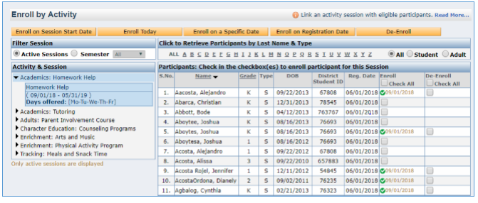
Enroll Students
Activities
On the left you will see a list of activities, select the one that you want to enroll students into; to the right you will see a list of students eligible to attend the session. Check the box in the “Enroll” column next to the student(s) you want to enroll in the class.

Once you have checked all of the students you can select “Enroll on Session Start Date” to enroll students on the first day of the session, or “Enroll Today” which would enroll students as of the current date or students can be “Enrolled on a Specific Date” or you can select “Enroll on Registration Date” to enroll the students on the date they registered.

If for some reason a student you selected can’t be enrolled, it will list the reason. For example, you select Enroll on Session Start Date but that student registered after the Session Start Date. Simply go back to the Enroll by Activity page, select the student and now select Enroll on Registration Date.

Enroll by Participant

Enroll by Participant allows you to enroll one student into multiple sessions at one time. To enroll by participant go to Enrollment ➔ Enroll by Participant. You will see the screen below.
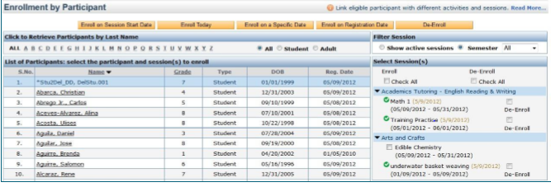
Eligible
Sessions
Students
On the left you will see a list of student names, select the student that you want to enroll into sessions and a list of eligible sessions will appear on the right.

Check the box in the “Enroll” column next to the sessions you want to enroll the student into.

Once you have checked all of the sessions you want to enroll the student into select “Enroll on Session Start Date” to enroll the student on the first day of the session, or “Enroll Today” which will enroll the student as of the current date or “Enroll on a Specific Date” to enroll on a desired date or you can select “Enroll on Registration Date” to enroll the student on the date they registered.

Enroll by Participant is especially useful when you need to only enroll a few students. For example, students who register late or throughout the school year.

Enroll by Activity is more efficient if you are enrolling many students as you do at the beginning of the year.

If a student is Registered but not enrolled there will be blue N next to their first name. Be sure to enroll them so they will be on your Attendance rosters.

Step Six Taking Attendance
Entering Attendance is one of the most important tasks you have in EZ Reports. The deadline for entering attendance is the 15th of the following month. For example, October’s attendance must be completed by November 15th at the latest. Attendance completion is monitored.
To enter attendance go to Attendance and select Record Attendance. The page below will appear. Select the week you need and then select Enter Attendance.
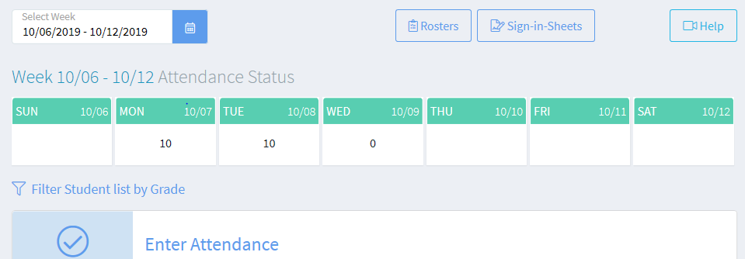

If you have selected the Record Present/Absent using Weekly Site Roster option for your Site Attendance then the following screen will appear. Complete attendance and select Save and Close.
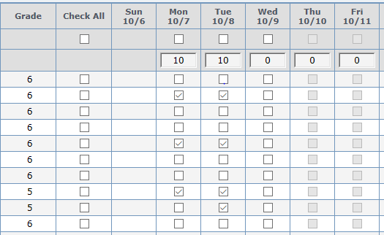
If you selected another Attendance option the Record Attendance page will look different. Check the UserGuides for help.
Upon completion of each month you need to Submit your attendance.
Submitting Attendance
To Submit the month’s attendance go to Attendance and select Review and Submit Attendance. The following screen will be displayed.
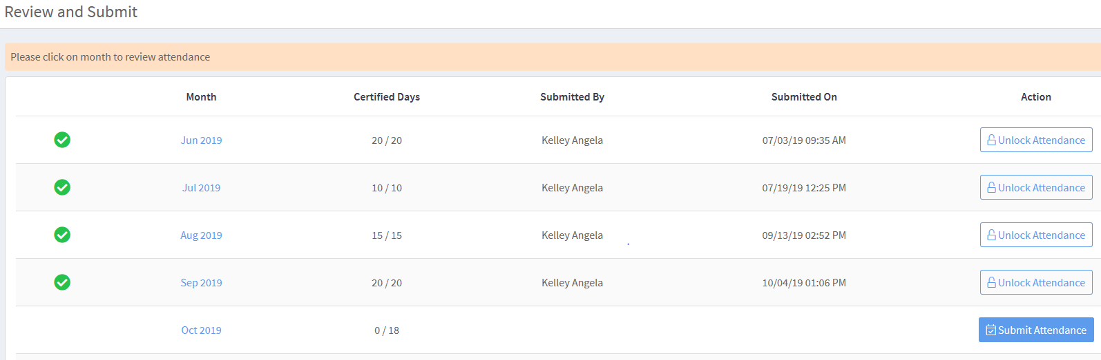
For instructions on how to complete this step go to the Support Videos available on the EZ Reports website.
Go to Support in the upper right-hand corner. See below
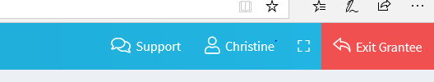
Click on Training Videos.
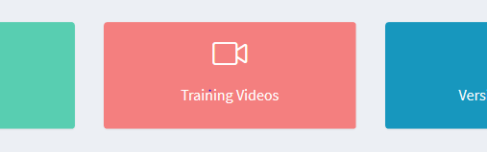
Select Review and Submit Attendance Video.
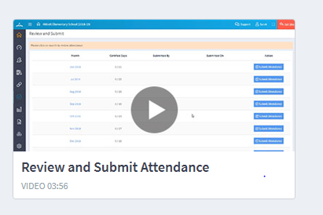
To unsubmit attendance
If you realize that you have some errors in your attendance and you need to make changes you need to unsubmit that month’s attendance. Unsubmitting attendance will not erase what you have already completed but give you the option to make changes. This can be easily completed on the Grantee Interface side of EZ Reports. If you have access to the Grantee Interface, you can do it yourself. If not, ask the person who does have access to do this for you.
To unsubmit Attendance.
On the Grantee Interface go to Reports select All Reports. Under Attendance select Status by Month. The following screen will appear.
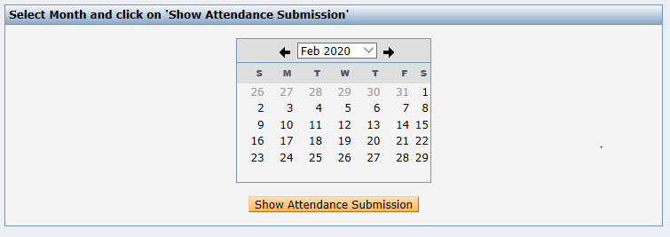
Select the month you need to unsubmit and click on Show Attendance Submission. The following screen will appear.
Click on Discard Submission. This will allow you to make changes to that month’s attendance. Once changes are made Review and Submit on the Site Interface.

Step Seven Edit/Add School Day Teachers
Day School Teachers (Teachers the students have during the school day)

Every year you must update the students’ Day School Teachers. The first year of the grant you must add them all. Subsequent years you can add or delete them according to need. All students must have one day school teacher linked to them in order to complete the teacher Survey. Linking students to teachers is an annual task as students have a different teacher each year.

Adding Day School Teachers.

On the Site Interface go to SetUp and select Day School Teachers. If you already have teachers on the page add or delete them according to the students you have this year.
To Add go to Add Day School Teacher
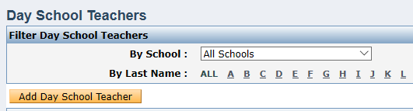

Then Complete the fields with the red asterisk.
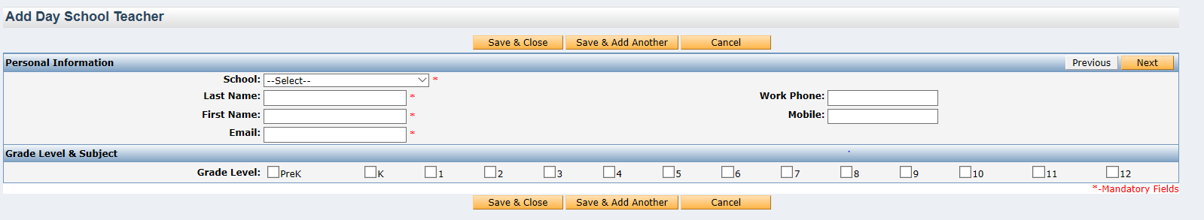
Save and Close or Save and Add Another.

To Delete a teacher go to the RED X to the far right of their name. If the X is gray that means the teacher is presently linked to a student and cannot be deleted.
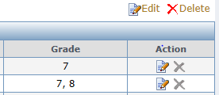
Linking Teachers to Students

To link a Day School Teacher to a Student go to Registration and select Students.
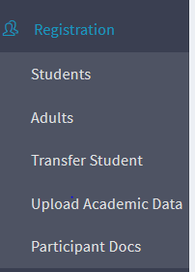

Go to the Action column to the far right of the student for whom you are linking the school day teacher. Select Edit-the paper and pencil icon.
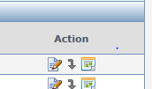

Next click on the Academic tab at the top of the page.
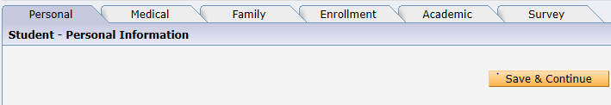
Select the appropriate teacher from the drop down menu and the grades she/he teaches. Be sure to check the Main/Primary Teacher box to signify the teacher to whom you will send the teacher survey. Save and close.
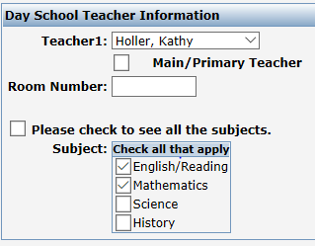

Step Eight Adding Parents/Adults
Adding Adults
There are two main methods for adding adults. Try to include email addresses whenever possible as that makes completing the Parent Surveys so much easier.
- Check to see if the adults are already in the program. (Previously held grant) On Site Interface go to Registration and select Adult. On the Adult page select Register Adult.
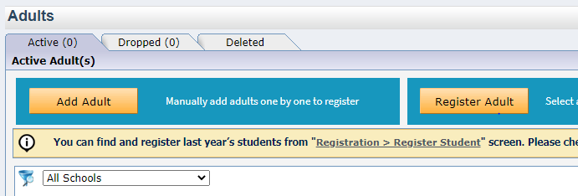
All adults registered in last year’s that have registered students in this year’s EZ Reports program will be on the list. Select returning parents/adults and click on Register. The window below will pop up. Be sure to enter a date on or before first session. Register Parent. The adults will now be visible on the Adult Registration page.
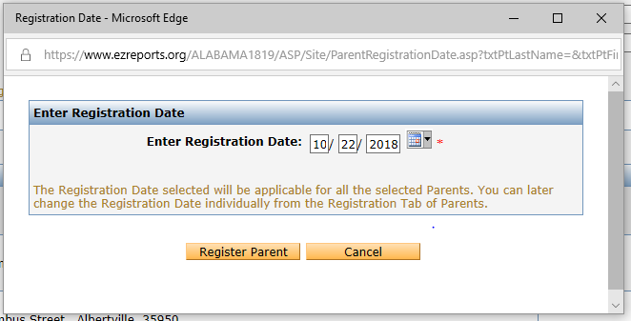

- To add new adults on the Site Interface go to Registration click on Adult and then Add Adult. Complete all the information with a red asterisk on the Personal page/ Then click on Save and Continue. Check to be sure the parent is linked to the correct students.
- To link parents you go to Registration/Student and click on the Edit icon for the student you want to link. Then select the Family tab and click on Link Registered Adult. Save & Close.

- 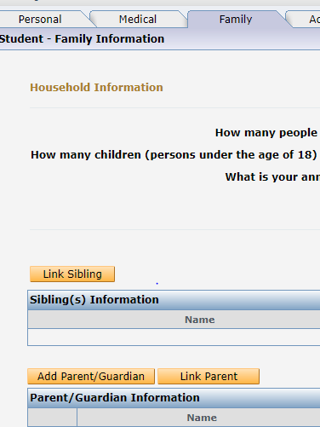

Adult Activities
There are two different types of Adult activities that you can select in EZ Reports.
- Special Event-This is used for those events where parents do not sign up (enroll) but show up that day. This might include events like Literacy Nights, Orientation, Stem Showcase, etc.
- Sessions/Classes-This is used when parents need to sign up (enroll) in a class. This might include parenting classes, ESL classes, computer classes, parent special interest activities, CPR training, etc.

Special Event Activities
To add a Special Event Activity go to Activity and select Special Events. Under Activity Information add the name of the Activity keeping in mind that activities are more general such as Parent Involvement or Parent Enrichment. When you add the sessions you will be more specific such as Literacy Night or STEM Showcase.
After adding the name click on Special Event and select Adult as your Target Audience. Complete all the remaining fields with red asterisks. Click on Save and Continue. This will take you to Objectives. Click on the Objective(s) that address this activity. Save.

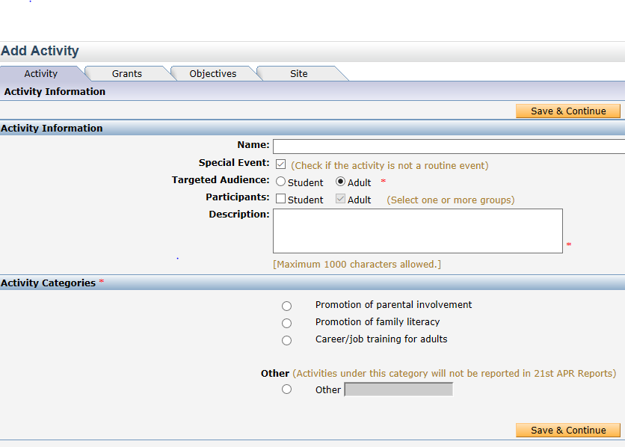
Once you complete this you will see the Activity on the Special Event Activity page. Now add the sessions. You will NOT ENROLL parents in these sessions. However, you will take attendance.
To take attendance on the Site Interface go to Attendance and select Special Event Attendance. To the far right of each session there will be one of these icons. Select the appropriate one. You will not be entering the adult who attended but the student to whom they are associated.
Adult Classes Activities
To add an activity for which you want adults to sign up/enroll go to Activity/Regular Activity and select Add Activity. Under Activity Information add the name of the Activity keeping in mind that activities are more general such as Parent Classes or Parent Enrichment. When you add the sessions you will be more specific such as Computer classes, Parenting classes, ESL, etc.
After adding the name do not click on Special Event. Do click on Adults as the Targeted Audience and Participants. Complete all the remaining fields with red asterisks. Click on Save and Continue. If you complete this on the Grantee Interface you will have four tabs to complete: Activity, Grant, Objectives and Site. If you do this on the Site Interface there will be only two-Activity and Objectives.
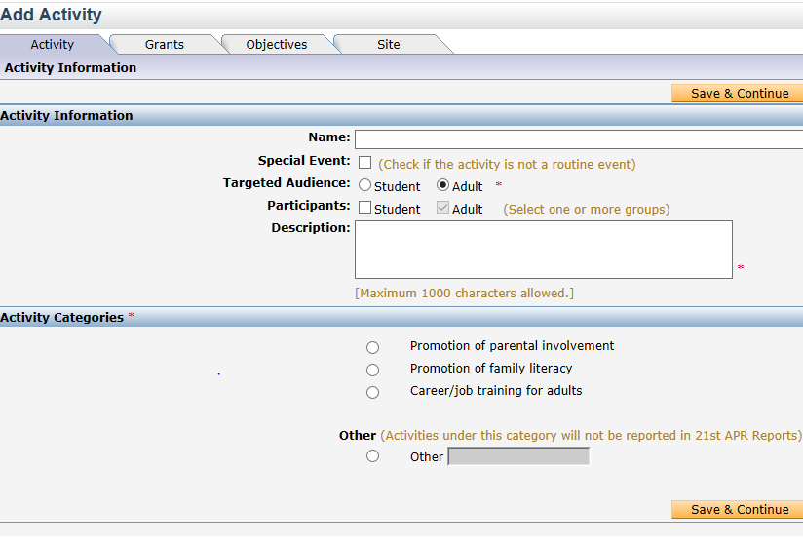
Once you complete this you will see the Activity on the Regular Activity page. Now add the sessions. Once the sessions have been added you need to enroll the adults in the sessions.
Go to Enrollment on the Site Interface and select Enroll by Activity. On the left-hand side of the page select the Activity/Session for which you want to complete enrollment. All the registered Adults names should be on the right-hand side of the page. Select the appropriate names and complete the enrollment process as you do for the students. They should now be enrolled.
To Take attendance you go to Attendance and select Record Attendance. Go to the date that the session was held. The adult names should be towards the bottom on that date.

The videos and User Guides are very helpful tools. You can access them by clicking on the Support button at the top right corner of any EZ Reports page.

